TWC Observations

- The redux store value gets reset when the user refreshes the page. So its better to reinitialize the session value right in the server(layout.tsx) after checking the session cookies instead of relying on the redux which will use a client component in the authSlice and won’t be able to read the cookie because the httpOnly is set to true during the creation of the cookie. It was set to make it more secure.

Command to download the images from the Instagram profile:
python -m instaloader --no-videos --no-video-thumbnails --no-metadata-json --post-filter="date_utc >= datetime(2025, 1, 1) and date_utc <= datetime(2025, 7, 31)" thewhiskcorner

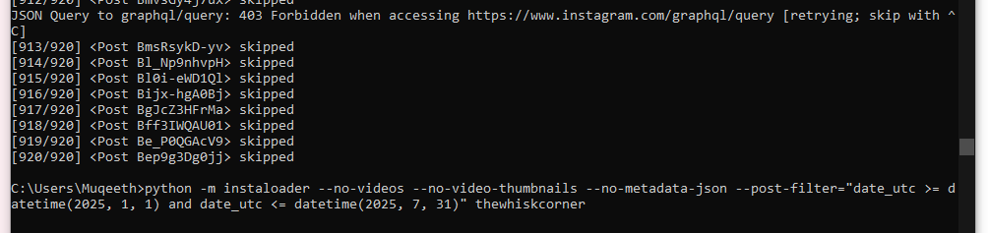

Command to run the seeding file with the help of seed.json document – npx tsx seed-db.js
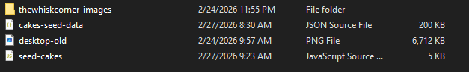

Use whisk AI to generate the image using the following prompt:
OBJECTIVE:
Generate a luxurious, high-resolution product image optimized for a bakery website hero banner (2.09 aspect ratio). This image is part of a 5-image carousel, so visual consistency across all outputs is critical. Keep all original label details sharp and readable.

COMPOSITION & FRAMING:

Final aspect ratio: 2.09 (banner format)
Position the cake on the right third of the frame, leaving generous negative space on the left for text overlay
Maintain the same camera angle, distance, and perspective across all 5 cake variations.

CAKE PRESENTATION:

Place cake on top an elegant white marble cake stand with a neck
Position the stand on a wide, smooth pearl white table which should be wide enough to cover the entire photo frame. Only table top should be visible and not the table legs.
Preserve all original label details - keep text sharp, crisp, and fully readable
Enhance resolution for professional sharpness without losing detail

STYLING & PROPS:

Scatter delicate flowers (roses, peonies, or similar luxury florals) on a soft linen or silk blanket draped naturally across the entire table
Flowers should frame the cake subtly - use good number of flowers but avoid overcrowding.
Use the same floral arrangement style and placement pattern for all 5 images to maintain carousel consistency
Props should feel organic, not staged - mimic editorial bakery photography

BACKGROUND DESIGN:

Modern, simple, geometric boxy/paneled wall design
Color palette: Soft blush pink (#f199b3)
Background pattern must be perfectly symmetrical and consistent across all 5 carousel images
Maintain the same lighting setup and wall design for visual cohesion

LIGHTING & ATMOSPHERE:

Soft, diffused natural bright lighting from the left side (to match right-positioned cake)
Gentle shadows that add depth without being harsh
Match the original photo's lighting quality - warm, inviting, professional
Consistent color temperature across all images (slightly warm, around 5500K)

TECHNICAL REQUIREMENTS:

Use generative fill to seamlessly expand canvas to 23:9 while maintaining photographic realism
Blend expanded areas perfectly with original image lighting, shadows, texture, and depth of field
Upscale to high resolution (minimum 3840x1500px) for crisp web display
Ensure consistency in grain, sharpness, and post-processing style across all 5 variations

BRAND AESTHETIC:

Elegant, luxurious, modern minimalist
Think high-end bakery brands: clean, sophisticated, Instagram-worthy
Evoke feelings of celebration, indulgence, and quality craftsmanship

Then use Google Photos to do the editing and https://dgb.lol/ to enhance the image.

